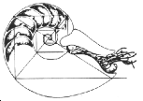 | Mathematical Biology Newsletter  Volume 14 #3 – September 2001  The Society for Mathematical Biology  http://www.smb.org  Edited by: Elizabeth H. Scholl
Table of Contents
Letter from the President - Mark Lewis

The World Outreach Committee Expresses Sorrow

The Akira Okubo Prize

Additional Guidelines for Okubo Prize - Mark Lewis

Non-Discrimination in SMB Funding

Guidelines for SMB Financial Support to Travel to Meetings
Other than the SMB Annual Meeting - Lisa Sattenspiel

Call for proposals – Meeting Support and Travel Funding

Guidelines for SMB Financial Support of Other Meetings
Organized by SMB Members - Lisa Sattenspiel

SMB Election Information - Sharon Lubkin

A Grad Student Perspective on the Hilo Meeting - Eric Cytrynbaum & Brad Peercy, University of Utah.

Notes from the 2001 Mathematical Models in Molecular and Cellular Biology,
Santa Fe Institute, Santa Fe, New Mexico, USA - Steven Kern, University of Utah

Meeting in Europe - Alan Hastings

Positions Available in Biomathematics - North Carolina State University

First International Workshop on Mathematical and Computing Techniques
for Agro-Food Technologies - November 26-27, 2001 - Barcelona, Spain

Mathematics and Molecular Biology VII - January 5-10, 2002, Santa Fe

University of Colorado at Denver and UC Health Sciences Center
Center for Computational Biology Workshop Announcement

Post Doctoral Research Assistant - University of Dundee, Dundee, Scotland, U.K.

Meetings in Immunology - Ramit Mehr

First Virtual Conference in Genomics and Bioinformatics -October 15 & 16, 2001

Postdoctoral Position: Theory of Resistance Evolution – University of Wisconsin, Madison

Computational Neuroscience Postdoctoral Research Associate Position –
The College of William and Mary

The Faces of the Society for Mathematical Biology

September, 2001
Dear SMB members,
At the Hilo annual meeting, Alan Hasting passed the torch on to me, and I am happy to serve you as President for the next two years. Thanks are due to Alan for his service as President, and for the smooth sailing in the last few years.

These are exciting times for mathematical biology, which remains very much a `growth area', especially if one includes the exciting new developments in genomics and computational biology. It is my hope that we can work to position the Society as a key player in the growth of mathematical biology, while still serving the needs and interests of our current members.

Thanks to Alex Mogilner for organizing a very successful annual meeting and International Conference on Mathematics in Biology at Hilo, Hawaii. This meeting was joint with the Japanese Association for Mathematical Biology. Over 200 people attended the meeting and there were about 100 poster presentations. The level of energy and excitement in our field of research shone at the meeting. A student's perspective of the meeting (authors Eric Cytrynbaum and Brad Peercy) is included in this newsletter.

I am pleased to announce that the 2002 SMB Annual Meeting will be at the University of Tennessee (Knoxville) from 13-16 July. The theme of the meeting is "Interdisciplinary Connections and Living Systems", and it will be under the organization of Lou Gross and other faculty from Tennessee. It will be preceded by a short course on the mathematics of biological complexity, designed for biologists. The Board hopes to soon have decided upon locations for subsequent years (2003 and 2004).

After many years of superb service to the Bulletin, Lee Segel is stepping down as Editor of the Bulletin of Mathematical Biology, which is owned by the Society. We are sad to see him leave the journal, which he built up and strengthened over time. I would like to thank him on behalf of all members of the Society. The Board of Directors and Committee to find a new Editor have unanimously recommended Philip Maini (Oxford) to be the new Bulletin Editor. Philip brings a wealth of experience and ability to this position and we feel he will do an outstanding job. Although we are awaiting final agreement from the publisher (Harcourt), we expect Philip to serve as the new Editor for a five-year term, starting January 2002. For more details, including the new submission address for papers, please check our web page www.smb.org as the information is added.

This newsletter contains information regarding upcoming elections. Sharon Lubkin has included a call for nominations for members of the Board of Directors and the President. I urge you to consider the nomination process seriously and to think of nominating yourself or a colleague.

Organizations often `outgrow' their bylaws. In the case of the Society, terms on the Board of Directors have evolved to four years, from the three-year term specified in the bylaws. Four-year terms allow elections to synchronize with the Presidential Elections (every two years), thus simplifying the election process. The next election ballot will include a portion where members can vote on updating the bylaws.

My best wishes for a happy and productive fall. Be sure to mark your calendars now for Tennessee 2002. If you have suggestions or questions regarding the Society, please don't hesitate to contact me at mlewis@math.ualberta.ca.

Mark Lewis
The World Outreach Committee Expresses Sorrow

The Society of Mathematical Biology (SMB), and particularly the World Outreach Committee, has an international character. Many members of our Society are US citizens or have studied or have research commitments in US Universities and Institutions or have friends living there. Therefore, the tragic events of September 11 in New York City and Washington affect us deeply.

We, the members of the World Outreach Committee of the SMB, express our deep sorrow, sympathy and solidarity to the people of the US for the tragic events and unequivocally condemn the cowardly act of terrorism that was perpetrated on innocent citizens.
The Akira Okubo Prize

The Second Akira Okubo Prize was awarded to Professor Simon Levin from Princeton University, during a special lunch on the first day of the Joint Meeting of the SMB and JAMB in Hilo, Hawaii, July 2001. The announcement of the Prize by Professor Yoh Iwasa is enclosed below:

President of the Society for Mathematical Biology
Secretary General of Japanese Association of Mathematical Biology

April 25, 2001
Dear Sirs,

We are pleased to announce that the Second Akira-Okubo prize committee has reached its conclusion.

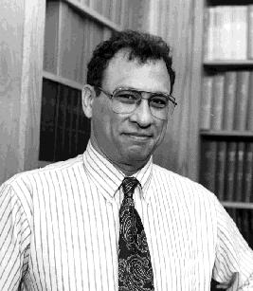
The procedure of selection was as follows: The committee is composed of six members: Mark Chaplain , Mark Lewis, and Philip Maini from SMB, and Toshiyuki Namba, Takenori Takada, and Yoh Iwasa from JAMB. We received eight nominations. First we discussed the procedure of selection. After examining the submitted material and exchanging our views on the suitability of candidates, each committee member raised top three candidates with scores. The results were clear -- all the members agreed concerning the top two. Then we focused on these two people and attempted to summarize their research achievements. Finally we voted. Through this procedure, we reached the conclusion that the winner of the second Akira-Okubo prize is
(picture taken from
Simon Levin’s Homepage)

Professor Simon A. Levin (Princeton University)

Professor Simon Levin graduated Johns Hopkins in 1961, and received his Ph.D. from the University of Maryland in 1964, both in Mathematics. Simon Levin became a professor in Ecology and Systematics, Cornell University from 1965. Since 1992, he has been teaching at Princeton University.

Beginning with his 1974 American Naturalist paper of the coexistence of competitors in a spatially structured population, Simon Levin has helped to establish the field of spatial ecology. His modeling of the inter-tidal zones with Robert Paine illustrated the importance of disturbances
(continued on next page)
(continued from previous page)

forming spatial patterns and the gap dynamics of mussel beds. It is now a classic study often seen in introductory ecology textbooks.

The best cited article by Simon Levin is his MacArthur Award paper published in 1992 in Ecology. Here he presented the importance of scales in understanding ecological patterns very clearly by raising a number of ideas and examples in ecology.

More recently, his collaborations with Rick Durrett brought new concepts to bear on ecological problems by emphasizing the importance of stochastic approaches to spatial ecological processes.

Simon Levin has had a long-term interest in group formation of animals. Rules for the behavior of individuals are translated into patterns observed in groups such as herds or swarms. However, the translation from the Lagrangian to the Eulerian framework is a great challenge. This is the field Akira Okubo pioneered.

Another area where Simon's work has been central to the development of a subject is the evolution of dispersal. Simon Levin and his colleagues established principles governing how variability leads to selection for dispersal, and explored new concepts in the field of evolutionarily stable strategies to do so.

In addition, Levin has also had made a major contribution towards the modeling of infectious diseases. His recent works includes a paper on the effect of antibiotic resistance on disease.

Recently, Simon Levin has been very influential in the area of modeling biodiversity and ecological sustainability.

Simon Levin is very talented in his ability to guide and inspire people as illustrated by a list of collaborators and students. He is also extremely flexible in the kind of mathematical formulation and type of analysis.

In addition to these research achievements, Simon Levin has been influential to mathematical ecology in many ways. He was President of the SMB from 87-89, just before his term as President of the Ecological Society of America. He was recently elected to a member of the US National Academy of Sciences.

The criteria for the prize says that the objective is to honor a scientist for "for outstanding and innovative theoretical work, for establishing superb conceptual ideas, for solving tough theoretical problems, and/or for uniting theory and data to advance a biological subject". We believe that Simon Levin meets all of these criteria.

Hence we are pleased to recommend Professor Simon A. Levin as the winner of the Second Akira Okubo prize.

Best wishes,
Sincerely yours,
Yoh Iwasa, Chairman, The Second Akira-Okubo Prize Committee

Additional Guidelines for Okubo Prize
by Mark A. Lewis

The Okubo Prize in mathematical biology honors outstanding researchers with a prize in memory of the math biology pioneer Akira Okubo. To facilitate the smooth administration of the prize, the SMB and Japanese Association for Mathematical Biology have agreed to the following guidelines for the Akira Okubo Prize. These are in addition to the existing rules governing the Akira Okubo Prize which are listed on the SMB web page (www.smb.org):

- The Okubo Prize winner is expected to give a talk to both the SMB and JAMB, with the Societies covering the respective costs. In the event of a joint talk to the Societies, the cost should be split between SMB and JAMB.

- Because

- there are three members on each of the JAMB and SMB parts of the Okubo Prize Committee,
- the rules specify that one from each part of the Committee should be replaced each year, and
- the Okubo Prize is awarded every other year,

there will be one individual in each of the JAMB and SMB parts of the Okubo Prize Committee that serve in both a current and previous Award process. This leads to continuity in the award process. These individuals, should be sure to inform the Secretary General of the JAMB or President of the SMB when it is time to specify the Chair of the Okubo Prize Committee and start the nomination process.

- Once the recommendation for the Prize winner has been made by the Okubo Prize Committee, the Chair of the Okubo Prize Committee should ask the Secretary General of the JAMB and President of the SMB to write a congratulatory letter to the candidate and should prepare the plaque and cash prize. Money to pay for the plaque and cash prize is to come from the Akira Okubo Prize Fund, administered by the Treasurer of the SMB.

Non-Discrimination in SMB Funding

Following reports of discrimination in selection of organizers and speakers at some meetings, the Board of Directors of the SMB has unanimously passed the following resolution: The SMB will support and fund only meetings and individuals' travel to meetings which do not prohibit participation at any level (e.g., organizer, presenter, attendee, etc.) on the basis of gender, race, age, nationality, ethnic background, religious belief or sexual orientation. Meeting organizers who request funding will be asked to sign a declaration to this effect.

Guidelines for SMB Financial Support to Travel to Meetings
Other than the SMB Annual Meeting
by Lisa Sattenspiel

Guidelines for support of SMB members to travel to meetings other than our annual meeting were clarified at the last Board meeting (July 2001). The following guidelines have been approved by the Board of Directors.
- Applicants must be members of the SMB for at least one year prior to requesting funds. Equal opportunity will be afforded all members with no discrimination on the basis of gender, race, age, sexual orientation, nationality, ethnic background, or religious belief.
- Preference will be given to junior scientists (students, post-docs, and non-tenured junior faculty) who do not have sufficient travel funds from other sources, such as grants. Senior scientists with insufficient travel funds may also be supported, but with lower priority.
- Applicants must be active participants in the meeting for which funds are requested (i.e., must be giving a paper or poster or attending a relevant course).
- Funding will normally consist of no more than $500 US of support per request.
- Priority will be given to individuals who have not received a travel grant from the SMB within the last five years.
- Deadlines for funding requests will be March 15, July 15, and November 15 of each year, with decisions to be made within the two months following.

Application materials to be submitted:
- A letter stating when and where the meeting will be held and how the proposed meeting will contribute to the applicant’s research. Indicate applicant’s professional status (i.e., undergraduate student, Master’s student, Ph.D. student, post-doc, etc.) as well.
- A copy of an abstract for a proposed talk or poster. If no abstract is available, indicate more specifically what will be done at the meeting and why attendance is important for future career goals.
- A copy of the applicant’s C.V.
- A statement of expected travel expenses, indicating the amount of funding received or requested from other sources.
- A letter of recommendation from applicant’s supervisor (if a student or post-doc) or colleague, including verification of applicant’s professional status and need to attend the meeting for which funds are requested

Send application materials to:
Lisa Sattenspiel Email: SattenspielL@missouri.edu
Department of Anthropology Fax: (573) 884-5450
107 Swallow Hall
University of Missouri
Columbia, MO 65211
USA
Note: If applying after August, 2002, please check website or newsletter for any changes in submission details.

Call for Proposals
The next deadline for Meeting Support Proposals and to request support to travel to meetings other than the SMB Annual Meeting is November 15, 2001. See details in this Newsletter.

Guidelines for SMB Financial Support of
Other Meetings Organized by SMB Members
by Lisa Sattenspiel

Guidelines for support of meetings other than our Society meeting were clarified at the last Board meeting (July 2001). The following guidelines have been approved by the Board of Directors.
- Theoretical biology must be a major component of the meeting.
- Meeting organizers must be members of the SMB for at least one year prior to requesting funds. Equal opportunity will be afforded all members with no discrimination on the basis of gender, race, age, sexual orientation, nationality, ethnic background, or religious belief.
- Supported meetings must not prohibit participation at any level (e.g., organizer, presenter, attendee, etc.) on the basis of gender, race, age, sexual orientation, nationality, ethnic background, or religious belief.
- Support must be made available to eligible participants on the basis of scientific merit and career needs only, with preference given to SMB members and with no discrimination on the basis of gender, race, age, nationality, or ethnic background. Women and minorities should be encouraged to apply, and meeting organizers must report to the SMB on the diversity of applicants and support recipients.
- Meeting organizers must raise funds from other sources to match the contribution of the SMB.
- Funds must be used preferentially to support travel of junior scientists (students, post-docs, and non-tenured junior faculty) who do not have sufficient travel funds from other sources. Senior scientists with insufficient travel funds may also be supported, but with lower priority.
- Funding will ordinarily consist of no more than $2000 US of support.
- Deadlines for funding requests will be March 15, July 15, and November 15 of each year, with decisions to be made within the two months following.

Application materials to be submitted:
- A letter stating when and where the meeting will be held, who is organizing the meeting, and the role of theoretical biology in the proposed meeting. Indicate also which members of the organizing committee are SMB members.
- Copies of the primary applicants’ C.V.’s.
- A budget indicating the projected expenses of the meeting and the amount of funding received or requested from other sources.

Successful applicants must send a final report within 30 days of completion of the meeting to the SMB describing how SMB funds were used and listing all applicants for support and the amount received by each.

Send application materials and reports to:
Lisa Sattenspiel Email: SattenspielL@missouri.edu
Department of Anthropology Fax: (573) 884-5450
107 Swallow Hall
University of Missouri
Columbia, MO 65211 USA

Note: If applying after August, 2002, please check website or newsletter for any changes in submission details.
SMB Election Information
by Sharon Lubkin

The Society for Mathematical Biology will be holding elections in Spring 2002 for one President-elect and three members-at-large of the Board of Directors. The SMB Nominating Committee is soliciting nominations for these positions from the SMB membership, and will compose an election slate of two candidates for President-elect and six for the Board members.

Each Director serves a 4-year term, and attends mandatory Board meetings each of those years. The President-elect serves one year as President-elect, two years as President, and one year as past-President, and also attends all Board meetings.

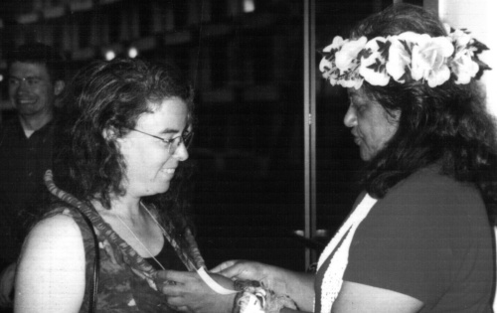
To nominate yourself or someone else for either position, send a 1-page letter detailing the nominee's strengths relevant to the position, including the nominee's history of service to the Society. Nominees must have been members of the SMB in good standing for at least 1 year prior to nomination. Nominees may have served on the Board or as President in the past, but may not be currently serving in those positions. Before nominating someone, make sure that they are willing to serve if elected.
Sharon Lubkin, left, Board member and Election Committee Chair

Letters must be received by November 1, 2001.
Send paper or electronic mail to:
Sharon Lubkin, Chair, Nominating Committee
Society for Mathematical Biology
Box 8203
North Carolina State University
Raleigh, NC 27695-8203 USA
lubkin@eos.ncsu.edu
A Grad Student Perspective on the Hilo Meeting
by Eric Cytrynbaum and Brad Peercy, University of Utah.

Shallow water waves and viscous flow of molten rock. Sounds more like a fluid dynamics meeting than the annual SMB gathering. But this year, the SMB and the Japanese Association for Mathematical Biology (JAMB) had the brilliant plan to meet halfway, in Hilo, Hawaii.

The official program lived up to all expectations with talks covering all scales of life and many corners of the world from rippling bacteria in the Bay area to patchy trees in Japan. Sessions on immunology, cancer and ecology (and many others) filled out the schedule. Many of us discovered just exactly how long 15 minutes is. Others learned to love Bill G. (did someone say "linux" or maybe even "chalk"?). And we all learned the meanings of Aloha.

Outside the lecture halls, another world awaited. Trips to the great waterfalls of the Big Island, Akaka Falls and Rainbow Falls, filled the afternoons as did hikes through Pele's wasteland of lava. Strolling on the crater floor or stumbling through the lava tubes, Volcano National Park is an experience from another world.

This idea of a midpoint meeting is pretty good. Next year in Tennessee?

(Photos at http://www.math.utah.edu/~eric/photo_album/hawaii/)
Notes from the 2001 Mathematical Models in Molecular and Cellular Biology
Santa Fe Institute, Santa Fe, New Mexico, USA.

Steven Kern, Department of Pharmaceutics, University of Utah, Salt Lake City, Utah

Under the direction of Lee Segel of the Weizmann Institute and Ellen Goldberg, President of the Santa Fe Institute, the 2001 Workshop on Mathematical Models in Molecular and Cellular Biology at the Santa Fe Institute began on 30 July. The workshop kicked off with a week of mathematical review for the mainly experimentalist attendees, followed by a week of topical lectures from experts in the field of mathematical biology. The review, or "Math Camp", as it was referred to by the participants, provided an excellent primer of the fundamental techniques that were used by the faculty presenters who participated in the second week of the workshop. The format of the workshop allowed for interaction among the participants and the faculty, providing a good environment for in depth discussion, exchange of ideas, and the potential for developing future collaborations.

This workshop was sponsored by the National Institutes of Health General Medical Sciences division under an initiatives to study complex biological systems. This is the first of five annual workshops funded at the Santa Fe Institute. Next year's focus will be directed toward theorists who are interested in learning more biological aspects of modeling. Information on this year's workshop can be found at http://www.santafe.edu/sfi/education/indexmathmodels.html Participants must apply for the workshop in advance so check the Santa Fe Institute's website at the beginning of next year for more information. With the interesting content, tremendous location, and the opportunity to take advantage of the great attributes of Santa Fe (food, hiking, biking, attending the Santa Fe Opera with Lee Segel), this is a workshop not to be missed.

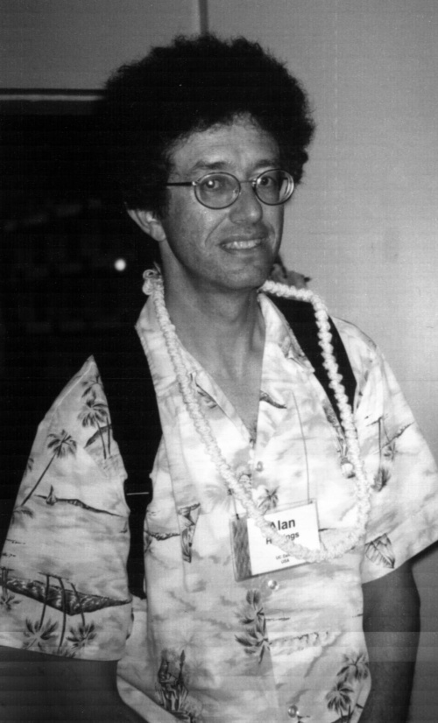
Meeting in Europe
Alan Hastings, Past President and Vice-President
by Alan Hastings

The European Society for Mathematical and Theoretical Biology (ESMTB) will be holding its next meeting at the beginning of July 2002 in Milan. The Society for Mathematical Biology has been invited to organize a special session, either half day or full day for this meeting. I was asked to serve on the scientific committee for this meeting as an SMB liaison, and have volunteered to organize a session, which will help to maintain ties with the European Society. A current plan is to have two half-day sessions, with a second co-organizer responsible for the other half-day. Unfortunately, funding is not available to defray the costs for speakers. I welcome suggestions and look forward to SMB being represented at this meeting.

Positions Available in Biomathematics

North Carolina State University

The Biomathematics Graduate Program invites applications for the position of Director and for one or more tenure-track positions in biomathematics. Candidates at all levels will be considered. Successful candidates must have a Ph.D. in a mathematical or biological science or related field, and a research program focused on modeling biological systems. Graduate level training of statistics and/or probability is important. Duties include research and teaching. Inquiries should be sent to gerig@stat.ncsu.edu. For more details and contact information see:
http://www.stat.ncsu.edu/admin/positions.htm#BMA

First International Workshop on
Mathematical and Computing Techniques
For Agro-Food Technologies

November 26-27, 2001 - Barcelona, Spain
http://www.cimne.upc.es/congress/food/

Agro-food Technology (AfoT) is a thematic area within MACSI-Net, an European Network supported by the Information Society Technologies Programme (IST) of the Fifth Framework Programme of the European Commission. MACSI-Net is an initiative to form an open network for the advancement of Mathematics, Computing and Simulation for industry.

Objectives:
The main aim of AfoT Workshop is to provide an introduction into the most important issues of the mathematical and computing techniques involving food technologies. These areas should contain all the conventional mathematical modelling and computer simulation techniques as well as signal processing methods.

The workshop is one of the activities of the MACSI-Net network to impulse unified mathematical and computing techniques involving food scientists, engineers and industrial people, as well as to encourage new cooperations at international level between companies and research institutions.

Workshop Topics:
The program will consist of keynote and invited lectures delivered by relevant scientist on the field. Program will cover the following topics:
- Modelling and Simulation of Unit Operations and Process Plants
- Food Process Optimization, Scheduling and Control
- Food Properties Measurements and Quality Control
- Simulation of Complex Processes (e.g. those requiring computational fluid dynamics, CFD)

Venue and Location:
The workshop will be held at CIMNE, in the North Campus of the Technical University of Catalonia, Barcelona, Spain. Several hotels will be available for the accommodation of the participants. More details should be requested to the workshop secretariat.

Mathematics and Molecular Biology VII

January 5-10, 2002, Santa Fe

The Program in Mathematics and Molecular Biology (PMMB) invites you to attend the conference:
Mathematics and Molecular Biology VII:
Modeling Across the Scales- Atoms to Organisms

January 5-10, 2002 at La Fonda Hotel, Santa Fe, NM

PMMB actively promotes interdisciplinary education and research through sponsorship and organization of the international conference series "Mathematics And Molecular Biology", held periodically in Santa Fe. The upcoming meeting is the seventh in the series, and is supported by the Burroughs Wellcome Fund Interfaces Program and the National Science Foundation. This meeting is intended to reach a broad multidisciplinary audience of students and researchers active at the interface between mathematics (broadly defined) and biology. One of the unique features of the meeting is an opening day of tutorials, which prepare the attendees for the lectures, with mathematical scientists introducing basic principles to biologists and biologists giving tutorials for the quantitative scientists. We are planning two sessions of special interest to students, focusing on issues of importance to students working at the interface between the computational sciences and biology. Students are especially welcome to attend and present posters on their work.

Meeting topics include:

Mathematics Tutorial
Biology Tutorial
Trainee Workshop
Modeling Molecules
Modeling Organisms
Bioinformatics
Single Molecules
Cellular Gene Expression
Mesoscale Modeling

Limited support is available for students and young faculty. For information and application forms, see our website: http://www.math.fsu.edu/~pmmb/
University of Colorado at Denver and UC Health Sciences Center
Center for Computational Biology

Workshop Announcement

To register and obtain more information, visit http://www.cudenver.edu/ccb/workshops.html

Title: Bioinformatics: Inference in High-throughput Molecular Biology
Organizer: Imran Shah, UCHSC Dept. Preventive Medicine & Biometrics / Dept. Pharmacology
Date: February 22, 2002
Location: Room 480, CU Building, 1250 Fourteenth St., Denver
Objectives: Build collaboration prospects between researchers in molecular biology and medicine with computer scientists, statisticians, probabilists and other quantitative people.
Target audience: Computer scientists, statisticians, probabilists and computationally inclined scientists who want to learn the challenging problems in molecular biology with medical applications (no background in molecular biology is assumed)

(continued on next page)
(continued from previous page)

Biomedicine is entering a new era of high-throughput data production. The macromolecular sequence databases are doubling in size every 18 months or so, and now contain more than 7 million sequences representing more than 9 billion nucleotides. Gene chips allow for the simultaneous assaying of the expression levels of thousands of genes at a time. Related technologies allow the identification of millions of point mutations in particular individuals, the simultaneous screening of tens of thousands of compounds for drug-like binding affinity, and the relatively rapid determination of three-dimensional macromolecular structures. The challenges inherent in analyzing this onslaught of extraordinarily interesting data are defining the new field of bioinformatics. Making biologically relevant inferences from massive data sets is a key aspect of the field, drawing on techniques from statistics, stochastic processes, pattern recognition, and machine learning. In this overview, several representative problems and solution techniques will be presented, including hidden Markov models, support vector machines, Bayesian networks, and pathway inference.

Post Doctoral Research Assistant
University of Dundee, Dundee, Scotland, U.K.

Applicants are invited concerning an EPSRC-funded project on the mathematical modelling and analysis of biochemical reactions. This interdisciplinary project involves researchers in Mathematics and Theoretical Biochemistry.

Biochemical reactions are vital components of all living systems. Almost all such reactions are mediated by enzymes and invariably form complex networks. Mathematical modelling has been successfully used to gain a better understanding of isolated reactions but little is known about the effects of external elements on such reactions. In order to better understand how these reactions function in their natural context, this project will examine the effects of certain external factors on the derivation and validity of classical reaction kinetics.

You will be based with Dr F A Davidson, Department of Mathematics and there will be extensive collaboration with Dr J. Liu, Scottish Crop Research Institute.

Candidates should possess a Ph.D. in Applied Mathematics or closely related topic. A background in modelling and/or analysis of ODEs and PDEs is essential. The appointment is for 18 months. Starting salary is 19,486 UKP on the RA1A scale.

Applications by CV and covering letter (2 copies), complete with names and addresses of 2 academic referees should be sent to:
Personnel Services
University of Dundee, Dundee
DD1 4HN, Scotland, U.K.
Quoting reference SE/266/1/N. Closing date 14th September 2001.

Informal inquiries to Dr F A Davidson e-mail: fdavidso@maths.dundee.ac.uk
or to Dr J. Liu e-mail: jliu@scri.sari.ac.uk.

Meetings in Immunology
by Ramit Mehr

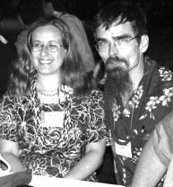
Members of the SMB apply their mathematical and computational skills in many areas of biology. For many of us, attendance of meetings of experimental biologists in our respective fields is highly informative, and in my opinion students and young researchers in mathematical and computational biology should be encouraged to attend such meetings. I would like to ask SMB members who are involved with various areas of biology to supply - for the benefit of all members – information about regular meetings in their respective areas of research, as this information is not covered by our lists of "theoretical" meetings. As an example, here is a list of regular meetings in immunology, which I find very helpful.
Ramit Mehr, Chair of Publications Committee, and Charlie Smith, Secretary.
(Photo provided by Charlie Smith)

Congresses: these tend to be large (thousands of participants) and cover many topics; the choice is sometimes overwhelming. However, if one focuses on the topics most relevant to one's research, these meetings may be very useful as much knowledge is accessible in a very concentrated form. In immunology, these include:

- The International Congress of Immunology organized by IUIS (Int'l Union of Immunological Societies). I just returned from ICI2001, which took place in Stockholm. These congresses are organized every three years - the next one will be in Montreal, Quebec, Canada in July 2004. See www.nrc.ca/confserv/immuno2004 for more details.

- Similarly, the European Federation of Immunological Societies (EFIS) organizes a large congress every three years. The next one will be in Rhodes Island, Greece, 8-12 June 2003.

- Keystone symposia (www.symposia.com) - a series of various conferences held in the Southwestern US every winter/spring in various ski sites - include a variety of meetings on immunological topics. I went to several of them, mostly those devoted to B lymphocyte immunobiology and disease, which took place every two years. These meetings tend to be smaller than the big congresses (only a few hundred participants) and focused on specific topics, which enables more depth and more interaction between participants.

- There are also the Gordon Conferences (www.grc.org), among which there are sometimes immunological meetings; however GRC topics include all natural sciences, and hence the diversity of immunological meetings is not as large as in the Keystone Symposia. (I personally have not been to a GRC other than the math biology one.)

- A series I recently heard about but haven't "tried" - on lymphatic tissues and germinal centers (www.14gcc.rug.nl) - details on the next meeting will appear on the website soon.

Once you go to a key meeting in your field, you'll find that in that meeting, the other meetings are advertised and it's easy to stay informed. Safe travel to everyone!

First Virtual Conference in Genomics and Bioinformatics

October 15 & 16, 2001

At World-Wide Access Grid Locations

Sequencing projects and genomics research has led to an explosive rate of data accumulation and to a shift in the way biological research is conducted. Bioinformatic tools of the post-genome era are providing new insights about gene expression patterns, intron/exon structure, post-translational changes and protein interactions as well as phylogenetic relationships. Parallel analysis of thousands of genes using microarray technology has become a multi-disciplinary endeavor in which unsupervised and supervised learning is applied for gene expression clustering and/or classification. Although genomic technologies offer an enormous scientific potential to understand organisms at the molecular level, new challenges on the horizon are envisioned. There is a need for improvement of microarray technology, data standardization, and tools for integration of multiple databases and data mining. Other necessary needs include the improvement of bioinformatic tools and statistical approaches for sequence analysis, gene annotation, categorization of protein families, protein-protein interactions, and phylogenetic studies.

The goal for the First Virtual Conference in Genomics and Bioinformatics is to increase the exchange of ideas and establish new ways of interaction and collaboration among scientists around the world.

For the 2001 Virtual Conference, topics include:
- Functional Genomics
- Structural Genomics
- Computational Approaches for Gene Expression Analysis
- Metabolic Profiling
- Genomic Data Standardization and Management
- Implications of Genomic Research
- Proteomics

Although registration is required, there are no required registration fees to participate in the conference. To participate at the Fargo Access Grid Node or one of several other Nodes around the world, please register through our web page:
http://www.ndsu.nodak.edu/virtual-genomics/registration.htm

Useful links:
Access Grid locations in the US and around the world:
http://www-fp.mcs.anl.gov/fl/accessgrid/ag-nodes.htm

Registration to attend the meeting in Fargo, North Dakota
http://www.ndsu.nodak.edu/virtual-genomics/registration.htm

Questions:

Edward_Deckard@ndsu.nodak.edu
Willy_Valdivia@ndsu.nodak.edu

More information can be found in SMB Digest volume 01 issue 16
Postdoctoral Position: Theory of Resistance Evolution

A postdoctoral position is available for a theoretical ecologist/evolutionary biologist to study the evolution of resistance of insect pests to genetically modified crops with insecticidal properties. The postdoc will participate with a team including an insect ecologist (David Andow), a sociologist (Fred Buttel), an economist (Terry Hurley), and a theoretical ecologist (Tony Ives). A strong background in mathematics is essential.

The position is for 2 years starting at US$30,000/yr, with the possibility of continued funding for additional time. The starting date is preferably before 1 March, 2002. All requirements for the Ph.D. must be completed before the time of appointment. Please send CV, and the names and contact information for 3 references to:

Tony Ives
Department of Zoology
UW-Madison
Madison, WI 53706

Phone: (608) 262-1519
Fax: (608) 265-6320
E-mail: arives@facstaff.wisc.edu

Computational Neuroscience Postdoctoral Research Associate Position

The College of William and Mary

Applications are invited for a two-year postdoctoral position in mathematical/computational neuroscience to work with Prof. Gregory D. Smith in the Dept of Applied Science at the College of William and Mary (http://www.as.wm.edu/Faculty/Smith.html).

Evidence of potential for quality research in neural computational modeling at the cellular or systems level is essential. Working knowledge of XPP, C, LATEX, MATLAB and the UNIX operating system are desired.

The successful applicant will be funded by NSF Division of Integrative Biology and Neuroscience to use a computational approach to investigate the function of visually-responsive inhibitory neurons located in the lateral geniculate nucleus (LGN) and have opportunity to collaborate with experimental visual neuroscientist S. Murray Sherman (SUNY, Stony Brook) and/or theorist John Rinzel (New York University).

For additional information or to apply email Prof. Smith greg@as.wm.edu and include:

- a full curriculum vitae including a list of publications and professional experience and
- names and contact information (preferably email addresses) for at least three references.

The Faces of the Society for Mathematical Biology

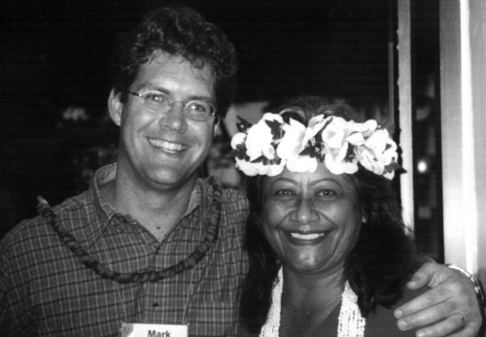


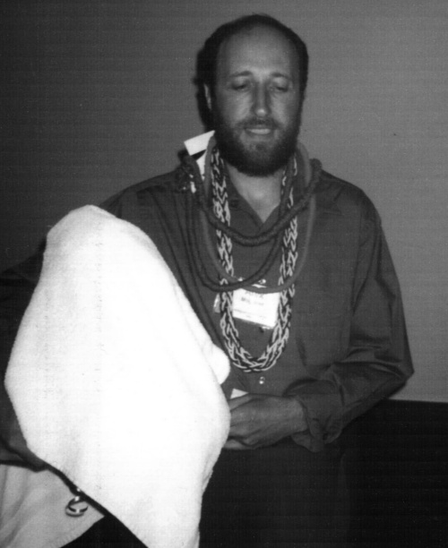
Mark Lewis, President, with Luau hostess
Gerda deVries,
Board of Directors,
Mentoring Program Chair
Suzanne Lenhart,
Board of Directors
SIAM/AWM Liaison
Alex Mogilner,
Conference Organizer

Most photos in this issue generously provided by Ramit Mehr. Photo of Simon Levin from http://www.eeb.princeton.edu/~slevin/ Photo of Charlie Smith and Ramit Mehr provided by Charlie Smith.

